Count number of nice subarrays
Problem Statement: Given an array nums and an integer k. An array is called nice if and only if it contains k odd numbers. Find the number of nice subarrays in the given array nums. A subarray is continuous part of the array.
Input :nums = [1, 1, 2, 1, 1] , k = 3
Output :2
Explanation :The subarrays with three odd numbers are [1, 1, 2, 1] [1, 2, 1, 1]
Algorithm
We can't directly count subarrays with exactly K odd numbers using one pass of sliding window. But we can count how many subarrays have at most K odd numbers. If we do this for both K and K-1, then the difference gives us the number of subarrays that have exactly K odd numbers. This works because: countExactlyK = countAtMost(K) - countAtMost(K - 1).
- Use a helper function to count the number of subarrays with at most a given number of odd numbers.
- Initialize two pointers to define the sliding window.
- Expand the window by moving the right pointer.
- If the number of odd numbers in the window exceeds the allowed count, move the left pointer to shrink the window.
- For each valid window, the number of subarrays ending at the current index is (right - left + 1).
- Repeat for K and K - 1, then return their difference.
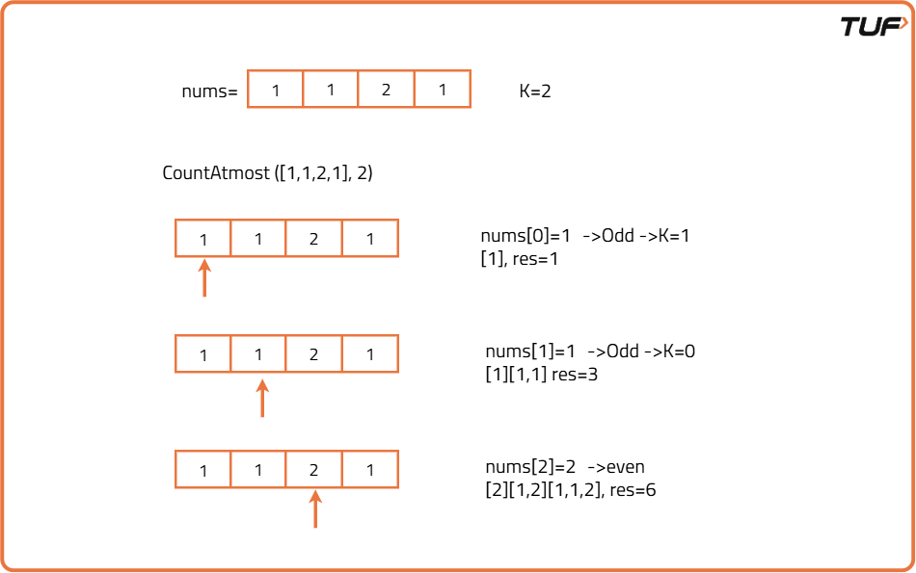
class Solution {
// Helper function to count subarrays with at most k odd numbers
public int countAtMost(int[] nums, int k) {
int left = 0, res = 0;
// Traverse through the array
for (int right = 0; right < nums.length; right++) {
// If current number is odd, reduce k
if (nums[right] % 2 != 0) k--;

// Shrink the window until k is valid
while (k < 0) {
if (nums[left] % 2 != 0)
k++;
left++;
}
// Add valid subarrays ending at right
res += (right - left + 1);
}
// Return result
return res;
}

// Function to return number of subarrays with exactly k odd numbers
public int numberOfSubarrays(int[] nums, int k) {
return countAtMost(nums, k) - countAtMost(nums, k - 1);
}
}
Time Complexity:O(n) ,We scan the array two times using the sliding window helper. Each scan processes every element at most once, making it linear in size of input.
Space Complexity:O(1) ,No additional space is used except a few integer variables for tracking window bounds and counts. So, constant space.

